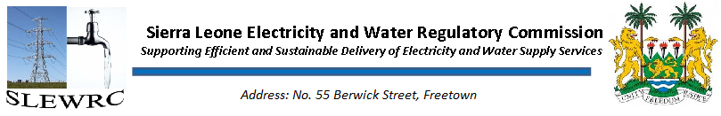
EWRC holds Quarter 2 RBF Steering Committee Meeting
The Electricity and Water Regulatory in collaboration with the Millennium Challenge Coordinating Unit (MCCU) held its Quarter Two RBF Steering Committee Meeting on Wednesday 4th March 2020 at the Sierra Leone Electricity and Water Regulatory Commission.
The meeting reviewed Quarter Two activities and verification result for Electricity Distribution and Supply Authority (EDSA) as presented by EWRC’s Head of Electricity Ing. Kelcise Sesay. The activities reviewed fell under Meter Installation, Technical Audit, Reporting to EWRC, Fault Clearance, Tariff review application payment metrics. The presentation also highlighted the methods of verification, observations in the course of executing each KPI, the challenges and proposal for improvement that would on EDSA activities
A second presentation was done by Ing. James Kamara of the Water Department on Guma Valley Water Company’s (GVWC) activities under the Increase in total collections, Increase in government collections, Leaks repaired, Saddled Connections, Installations of sub-mains/pipe extensions, Reporting to EWRC and Tariff review application payment metrics.

A final presentation on the EWRC Q2 verification results was done by Mr. Salieu Barrie the Head of Finance and Administration informing that the verification approach was desk based analysis of the various payment metrics ranging from Submission of regulations, Passing of regulations, analysis of utility reporting, support to independent verifier, performance monitoring of utilities, Perception of EWRC, Outreach with the general public, Tariff Applications payment metrics.
Based on the verification results, the incentive payments calculated to be made to Regulator and each of the utilities are as follows:
- EDSA - $105,519 excluding the adjustment to be done for Support to the Independent Verifier payment metric
- GVWC - $305,000
- EWRC - $36,000

The CEO Mrs of MCCU, Ndeye Koroma informed the committee that on submission of the minutes MCCU would commence its own processes reflecting changes to be made to determine the final payments for all the entities and to make a submission to the MCC to commence their own process for the disbursements.

It should be noted that the Results-Based Financing Activity is designed to complement the technical assistance inputs provided under the Regulatory Strengthening Project by giving the regulator key performance indicators by which they can assess the sustainability of capacity improvements and knowledge transfer at implicated utilities through conditional, performance-based disbursements to such utilities if they achieve to-be-negotiated key performance indicators (KPIs). In doing so, the Activity will also strengthen and reinforce the Electricity and Water Regulatory Commission (EWRC’s) role as sector regulator and incentivize improved utility performance.

